EMBARGOED until June 11, 2019 12:01 AM EDT
Twelve Years After Landmark Treaty on Rights of Persons With Disabilities,
UCLA WORLD Policy Analysis Center Finds Evidence of Marked Progress, but Gaps Remain That Leave More Than 160 Million Behind

The first comprehensive human rights treaty of the 21st century, the Convention on the Rights of Persons with Disabilities (CRPD) stands as one of the most quickly ratified human rights treaties in history. Globally, according to the United Nations (UN), approximately four billion people are affected by disability policy—including one billion persons with disabilities, one billion who are aging and at high risk of developing a disability, and two billion close family members and caregivers. But, in the 12 years since its adoption in 2006, have countries taken critical steps to realize the transformative promise of the CRPD and guarantee equal rights to all persons with disabilities?

This will be a key question at this week’s 12th Session of the Conference of States Parties to the CRPD, the annual gathering for the 177 countries that have ratified the CRPD, which has become the largest and most diverse international disability meeting in the world.

On June 12 at the UN in New York City, the UCLA Fielding School of Public Health’s WORLD Policy Analysis Center (WORLD) will release the first comprehensive look at laws governing rights to nondiscrimination, inclusion and reasonable accommodations at school and work for all 193 UN member states. These rights are fundamental to fulfilling national commitments to the CRPD as well as other global commitments to education, dignified work and nondiscrimination.

Yet, the WORLD report finds that while many countries have taken important steps to align national laws with the CRPD, others have not yet gone far enough in enacting legislative and constitutional protections in critical areas. As one example, nearly half of all countries do not require employers to guarantee reasonable accommodation to workers with disabilities—leaving more than 160 million persons with disabilities without guarantees to these critical supports. Further, the report finds that guarantees to persons with disabilities lag behind guarantees on the basis of other aspects of identity. Among WORLD’s findings:

- Globally, and among countries that have ratified the CRPD, only 27% of constitutions explicitly guarantee equality or nondiscrimination on the basis of disability. This proportion has increased since adoption of the CRPD; in 2007 (a year after the CRPD was adopted), only 32 constitutions explicitly guaranteed equality and nondiscrimination for persons with disabilities. Over the course of the last 10 years, constitutional protections have steadily increased to 40 constitutions in 2011, 47 in 2014 and 52 in 2017.
- Constitutional rights can be powerful tools to reverse discriminatory laws and policies, shift social norms toward inclusion and more. Yet, guarantees to persons with disabilities still lag behind those extended to other groups, even among more recently adopted constitutions. Between 2010 and 2017, 100% of new constitutions explicitly guaranteed equality on the basis of gender, as did 92% on the basis of religion and 79% on the basis of race/ethnicity—compared to 71% on the basis of disability.
Does the constitution explicitly guarantee equality or nondiscrimination for persons with disabilities?
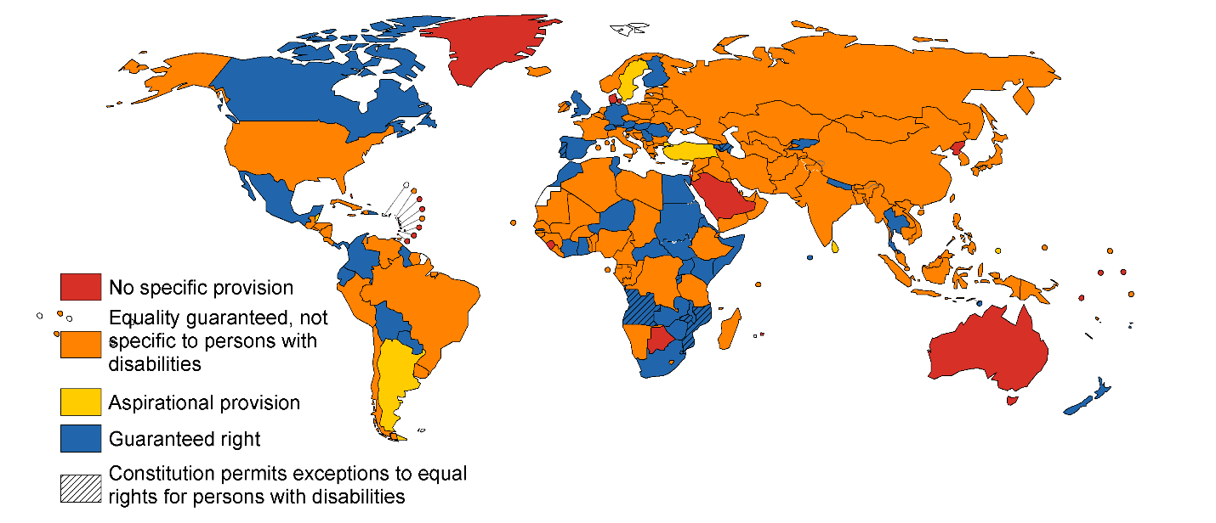

- Globally and among countries that have ratified the CRPD, one in five countries do not guarantee students with disabilities the right to education in integrated, mainstream environments through the completion of secondary education. The right to education is clearly outlined in the CRPD and inclusive education supports strong learning outcomes for children both with and without disabilities.

What is the guaranteed level of inclusion through the completion of secondary education for students with disabilities?

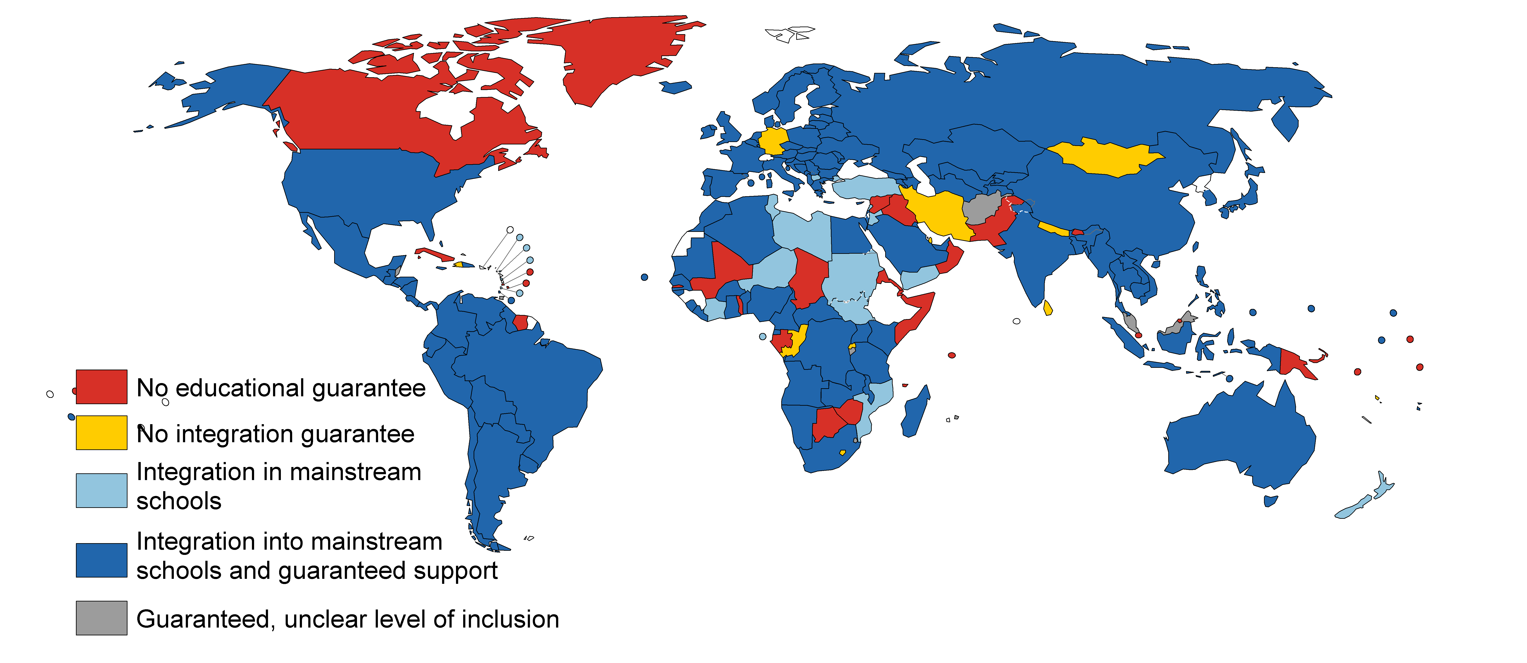

- Nearly two-thirds of all countries (63%) and 66%of countries that have ratified the CRPD take steps to prohibit discrimination in hiring on the basis of disability.
- Globally and among countries that have ratified the CRPD, nearly half do not require employers to guarantee reasonable accommodation to workers with disabilities―leaving more than 160 million workers with disabilities without guarantees to these critical supports. Reasonable accommodations at work are job adjustments made for individual workers with disabilities, such as ensuring physical accessibility or providing assistive devices; these are typically low-cost and cannot impose an “undue hardship” on employers.

Are employers required to provide reasonable accommodation to workers with disabilities?
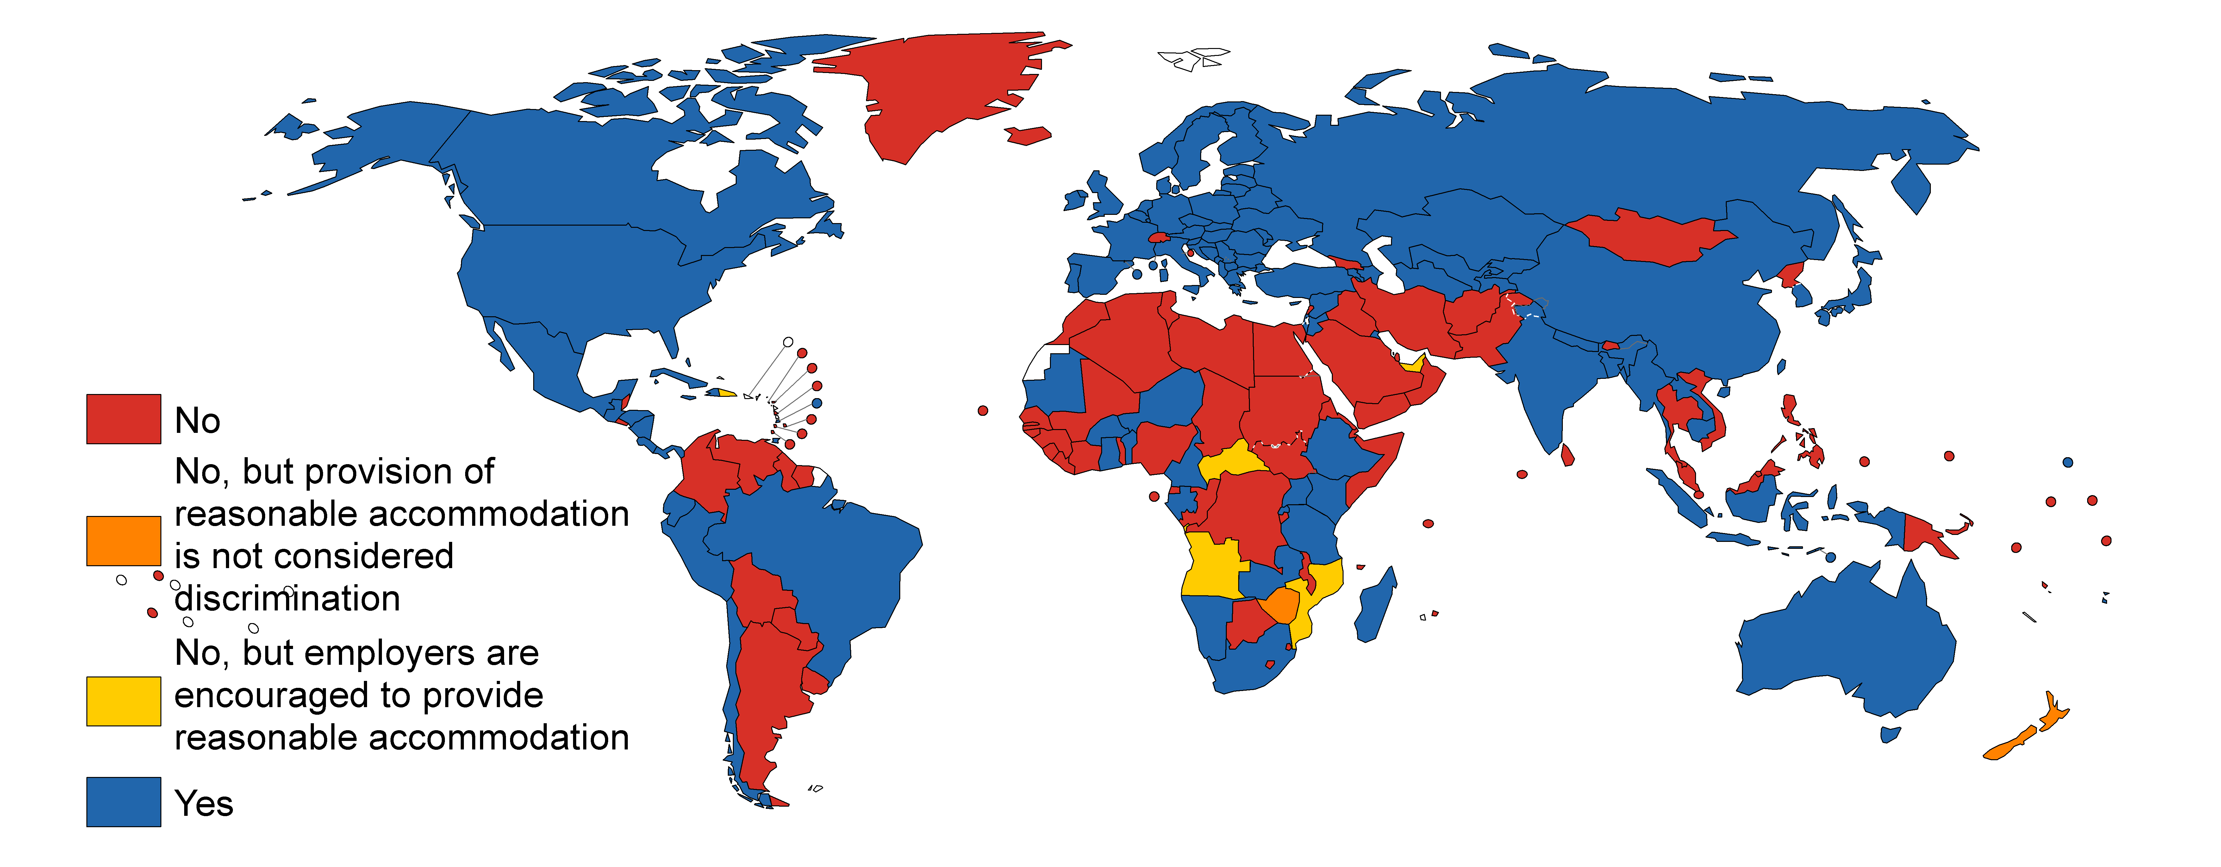

“Every child on the planet has the right to fully accessible, quality education and every adult has the right to dignified work without discrimination, but not all countries are fulfilling these rights,” said Dr. Jody Heymann, founding director of the WORLD Policy Analysis Center and a distinguished professor in the UCLA Fielding School of Public Health. “Our analysis shows that the world is further behind in guaranteeing these fundamental human rights to persons with disabilities when compared to other groups. While the global community has made progress, countries must go much further to dismantle barriers to full inclusion for education and work.”

To assess the steps that countries are taking to prohibit disability-based discrimination and guarantee inclusion at school and work, WORLD conducted a comprehensive review of 193 national constitutions and more than 700 articles of legislation and statutory regulations. Key findings from the report include:

Laws Guaranteeing Nondiscrimination and Inclusive Education
- Discrimination and exclusion contribute to lower education attainment, which is linked to fewer economic opportunities and increased social marginalization. Yet, 46% of countries do not prohibit discrimination on the basis of disability in education through the completion of secondary school.
- Globally, 65% of countries guarantee students with disabilities the right to education in integrated, mainstream schools with guaranteed supports through secondary education. While 94% of countries in Europe and Central Asia provide such guarantees, only 37% of Middle East and North Africa countries do so.

Laws Guaranteeing Nondiscrimination and Reasonable Accommodation at Work
A slight majority of countries prohibit discrimination on the basis of disability broadly (62%) and/or specifically in hiring (63%)—but 26% do neither. Guarantees in specific areas of employment vary:
- Nearly half (47%) of countries explicitly prohibit disability discrimination in pay, as do 55%in terminations and 47% in promotions and/or demotions.
- Far fewer, 30%, prohibit disability-based harassment in the workplace, and just 33% prohibit indirect discrimination.

Gaps also persist in guarantees of reasonable accommodations:
- Just over half of all countries (52%) require that employers provide reasonable accommodation to workers with disabilities.
- Regionally, there is noticeable variation in guarantees of reasonable accommodation: While 91% of countries in Europe and Central Asia provide such guarantees, only 21% of Middle East and North Africa countries do so.

Although the WORLD report identifies important gaps between the promise of CRPD and the steps countries have taken to ensure the rights of persons with disabilities, the progress that has been made in the 12 years since the landmark treaty is significant. “The CRPD has ushered in one of the most significant legal reform movements in history,” said Dr. Michael Ashley Stein, co-founder and executive director of the Harvard Law School Project on Disability. “This new data from the WORLD Policy Analysis Center is the best study of its kind, and the first to comprehensively examine laws and policies in every country. It is a powerful tool that can be used as a blueprint for progress by policymakers and civil society, including every disabled people’s organization around the world, to build on global law reform and continue the CRPD’s transformative agenda for disability equality.”

The WORLD Policy Analysis Center is the first and largest data center to provide quantitatively analyzable data on policies in all 193 UN member states in a range of critical areas, including education, health, environment, poverty, families, adult labor, marriage, childhood, child labor, equal rights and discrimination, aging, disability and gender.

The UCLA Fielding School of Public Health, founded in 1961, is dedicated to enhancing the public's health by conducting innovative research, training future leaders and health professionals from diverse backgrounds, translating research into policy and practice, and serving our local communities and the communities of the nation and the world. The school has 650 students from more than 35 nations engaged in carrying out the vision of building healthy futures in greater Los Angeles, California, the nation and the world.

